***Midterm report***

***Group members:***

Nguyen Thanh Vang ITITIIU17063

Vo Hoang Hai ITITIU17005

Le Doan Anh Khoa ITITIU17010

Class: Wednesday morning

***Assignment Topic F: Home Delivery Food***

***Part I: ERD Diagram***

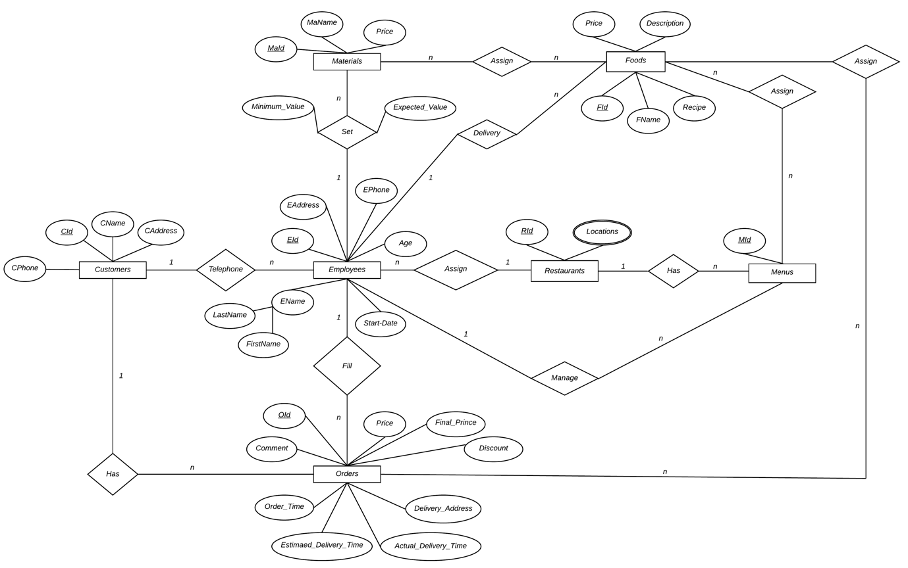

***Part II: Mapping to relational model ( schema )***

***Customers***( CId, CName, CAddress, CPhone, Telephone_Staff_Id)

***Employees***( EId, EAddress,EPhone, Age, LastName, FirstName, Start_Date)

***Restaurants***( RId, EId)

***Orders***( OId, Price,Final_Price,Discount,Delivery_Address, Order_Time, Estimated_Delivery_Time, Comment, CId, Telephone_Staff_Id)

***Menus***( MId, Manager_Id, RId)

***Foods***(FId, FName, Recipe, Price, Description, Delivery_Staff_Id)

***Materials***( MaId, MaName, Price, Minimum_Value,Expected_Value, Manager_Id)

***OrdersWithFoods***(OId, FId) PK(OId,FId)

***MaterialsWithFoods***( MId, FId) PK(MId,FId)

***MenusWithFoods***( FId, MId) PK(FId,MId)

***Locations***(location, RId) PK(location,RId)